Titanic Dataset (Data Preprocessing)
Source: Kaggle Titanic train.csv (891 rows, 12 columns). Scope: missing values, categorical encoding, feature scaling and train/test split. No model training.

1. Column Classification
Column | Type | Notes
PassengerId | Identifier | Unique per row, dropped
Survived | Binary (target) | 0 = died, 1 = survived
Pclass | Ordinal | 1 > 2 > 3 (ticket class)
Sex | Binary | male / female
Embarked | Nominal | S, C, Q (no inherent order)
Age, Fare | Numerical (continuous) | Different ranges and skew
SibSp, Parch | Numerical (discrete) | Family counts
Name, Ticket, Cabin | Text / high-cardinality | Mostly unique values (not valuable)

2. Missing Values
Column | Missing | Percent | Treatment and justification
Age | 177 | 19.9% | Median Age grouped by Title (extracted from Name). Age depends strongly on title (e.g. Master â‰ˆ 3, Mr â‰ˆ 30); median is robust to skew.
Cabin | 687 | 77.1% | Too sparse to impute. Replaced by binary HasCabin flag; raw column dropped. Missingness is informative (cabins mostly recorded for higher classes).
Embarked | 2 | 0.2% | Filled with the mode (S), the standard choice for a categorical column with negligible missingness.
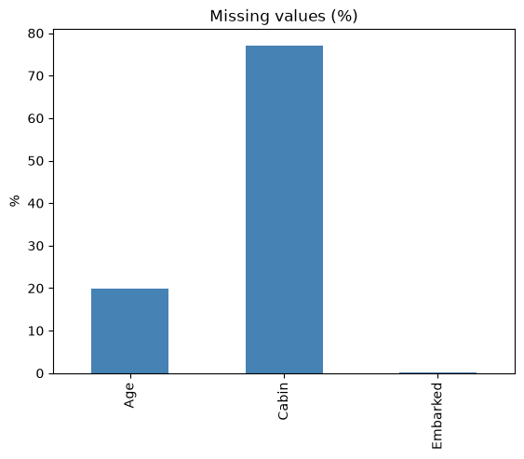
Figure 1: Percentage of missing values per column
All imputation values (Title medians, Embarked mode) are computed on the training set only and then applied to both sets, so the test set does not influence preprocessing. After imputation no missing values remain, apart from the dropped Cabin column.

3. Categorical Encoding
Variable | Encoding | Reason
Sex | Binary label (male = 0, female = 1) | Only two categories, so a single column is enough.
Embarked | One-hot (3 columns) | Nominal; label encoding would imply a false order S < C < Q.
Title | One-hot (5 columns) | Nominal; rare titles grouped as "Rare".
Pclass | Kept as 1, 2, 3 | Ordinal; the integer order already reflects the class order.
Name, Ticket, PassengerId | Dropped | High-cardinality text or identifier with no generalisable signal.

4. Feature Scaling
Age, Fare, SibSp and Parch were standardised with StandardScaler (mean 0, standard deviation 1), fitted on the training set only.
- Why needed: the features sit on very different ranges (Fare up to about 512, Age up to 80, Parch up to 6). Distance-based and gradient-based models (KNN, SVM, logistic regression, neural networks) would otherwise be dominated by large-valued features.
- Not needed for tree-based models (decision tree, random forest), which are insensitive to feature scale.
- Not scaled: Sex, HasCabin and one-hot columns (already 0/1) and Pclass (small ordinal range).
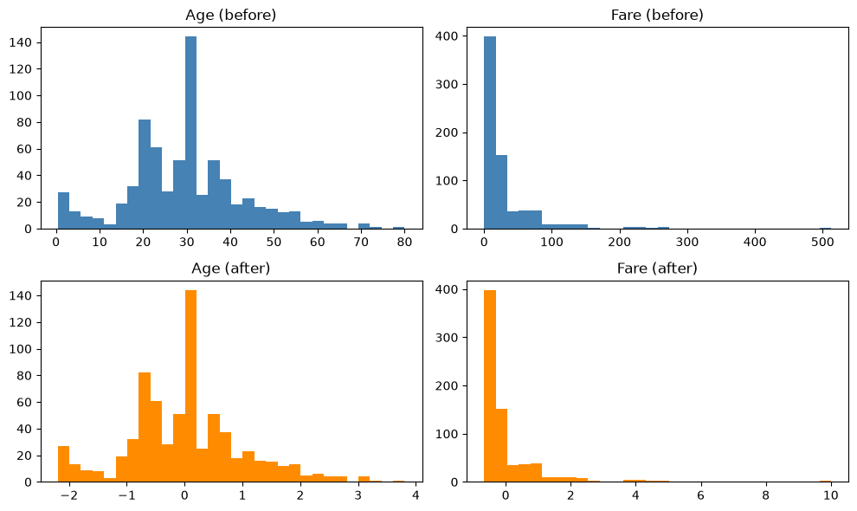
Figure 2: Age and Fare before and after standardisation
The distribution shape is unchanged. Only the scale moves, to a mean of 0 and standard deviation of 1. Fare remains right-skewed; a log transform could be considered for some models but was outside the scope of this task.

5. Train / Test Split and Final Output
- 80 / 20 split with random_state = 42, stratified on Survived to preserve the class ratio (38.3% vs 38.5% survival in train and test).
- X_train: 712 Ã— 15, X_test: 179 Ã— 15, y_train: 712, y_test: 179.
- Final features: Pclass, Sex, Age, SibSp, Parch, Fare, HasCabin, Embarked (C, Q, S) and Title (Master, Miss, Mr, Mrs, Rare).
- No missing values in the processed data. Files saved: X_train_processed.csv, X_test_processed.csv, y_train.csv, y_test.csv.

